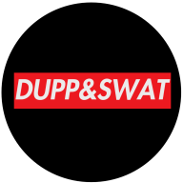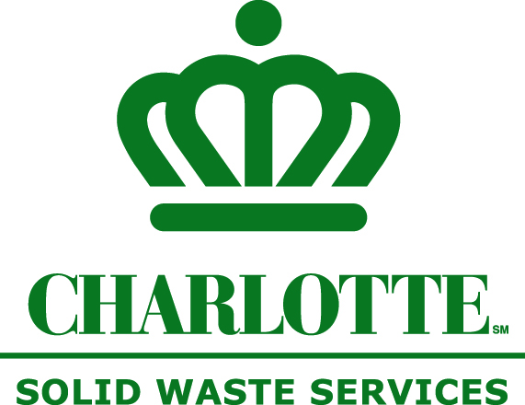**Junk to Jewels, Local Designers Square Off**

City Solid Waste Services and Dupp & Swat Hosts…

**2nd Annual #REPURPOSED: An Upcycled Fashion Show + Auction**

**FOR IMMEDIATE RELEASE**

**Contact:** Denada Jackson

704-432-3538 (PH), 704-363-5104 (C)

[djackson@charlottenc.gov](https://email.charlottenc.gov/owa/redir.aspx?SURL=vuQhOoU7D3Pq1VmpAbMb3XLKudChcioRMzQCh4YyFuiytDpwN7LSCG0AYQBpAGwAdABvADoAZABqAGEAYwBrAHMAbwBuAEAAYwBoAGEAcgBsAG8AdAB0AGUAbgBjAC4AZwBvAHYA&URL=mailto%3adjackson%40charlottenc.gov)

**Charlotte, NC (Feb. 26, 2018) -** Last year, nearly 300 people watched and bid on items that were transformed from rubbish to couture fashion at #**REPURPOSED**: An Upcycle Fashion Show + Auction. These pieces were created by local designers who competed for cash and bragging rights. This year, 15 designers will vie for the title of upcycle king or queen on **March 10 at 5:00 p.m. at Warehouse 242, 2307 Wilkinson Blvd**.

Presented by the [City of Charlotte Solid Waste Services](http://curbit.charlottenc.gov) and[Dupp & Swat](http://www.duppandswat.com/), #**REPURPOSED** educates local residents on upcycling and encourages them to consider this option as a way to reduce waste and improve their health.

**Here’s how it works.**

[Goodwill® Industries of the Southern Piedmont](http://www.goodwillsp.org/) allows competing designers to select discarded items from their stores in order to transform those items into couture clothing and accessories. Designs are showcased at #**REPURPOSED** and bid on by attendees. Dollars go to [CrownKeepers](http://www.crownkeepers.org/), a nonprofit dedicated to the creation, mobilization and sustainability of artists in the Queen City. Winning bidders can keep garments to rock their own runways. The designer of the piece that gets the highest bid wins the competition.

**Why the city’s on a Path to Waste Reduction.**

The city’s Environmental Committee seeks to divert waste from the landfill, increase composting and promote waste options. One way to bring awareness to this goal and help make this vision a reality is by stressing the importance of upcycling, recycling, reusing and composting in fun and creative ways. The more than 218,000 households served by the City of Charlotte Solid Waste Services generate 1,600 pounds of garbage per household per year. This trash goes to the landfill where methane gas and leache, trash juice, is created causing air, soil and water pollution. This pollution can be linked to chronic diseases, including cancer, heart disease, stroke, kidney disease and diabetes, proving there is a direct connection between your health and the environment.

One way to improve personal and environmental health is to manage waste better. If each household reduces their garbage by 16 pounds per year nearly 1,744 tons of garbage can be diverted from the landfill.

Solid Waste Services is teaching citizens practical ways to manage waste better through the [Healthy Communities program](http://www.healthycommunitiesclt.com), which uses #**REPURPOSED**, the Food Too Good To Waste Challenge, games, school presentations, workouts and cooking classes to educate and inspire change in waste behaviors. Those who have participated in the challenge and followed tips they learned in classes have lost weight, saved money on groceries and felt better overall. [Our next challenge kick-off event is March 8](http://www.healthycommunitiesclt.com/new-events/).

For more information about #**REPURPOSED** go [repurposedclt.eventbrite.com](https://www.eventbrite.com/e/repurposedclt-upcycled-fashion-furniture-show-tickets-40752647265). To read more about the city’s Healthy Communities program visit www.healthycommunitiesclt.com.

###